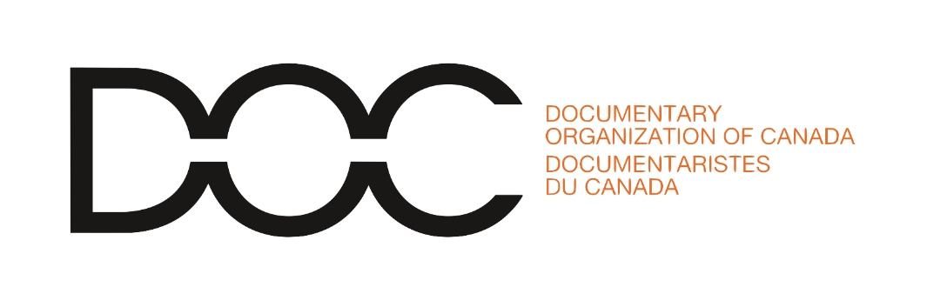

September 29th, 2021

Dear Minister,

In 2015, the Truth and Reconciliation Commission put forward 94 Calls to Action. As of today, just thirteen have been put into effect.

Call to Action 80: to Establish a National Day for Truth and Reconciliation as a statutory holiday went into effect on June 3rd, and September 30th, 2021 is the first National Day for Truth & Reconciliation.

In honour of this day, and in recognition of Canada’s long and horrific genocidal policies towards First Nations, Métis and Inuit Peoples, I call for Canada’s politicians to take immediate action on the remaining 81 Calls to Action of the Truth and Reconciliation Commission. Canadians must not be silent, and we must take action now. These Calls to Action are basic human rights.

More than 150,000 First Nations, Métis, and Inuit children were placed in schools between the 1870s and 1990s and in May 2021, new proof of the horrors of these institutions confirmed what communities already knew about the number of children who were buried in unmarked or mass graves. Of the five Calls to Action related to Child Welfare, not a single one has been completed. These are: Reduce the number of Aboriginal children in care; Publish annual reports on the number of Aboriginal children in care; Implement Jordan's Principle; Establish national standards for Aboriginal child apprehension and custody cases; Develop culturally appropriate parenting programs for Aboriginal families. Of the seven Calls to Action related to Education, not a single one has been completed. These are: Repeal the 'Spanking Law'; Eliminate educational and employment gaps; Eliminate the discrepancy in federal education funding between on-reserve and off-reserve students; Publish annual reports on education funding and educational and income attainments; Draft new Aboriginal education legislation; Provide adequate funding for First Nations students seeking post-secondary education; Develop culturally appropriate early childhood education programs.

I am one of over 1,000 members of the Documentary Organization of Canada (DOC). For the past 38 years, DOC has been the voice of and leading advocate for Canada’s independent documentary community. With 6 chapters from coast to coast, DOC is a community that connects and strengthens documentarians across the country and our work drives critical thinking about the ethics, practice, and aesthetics of documentary storytelling. DOC is committed towards making our best efforts to incorporate the 94 calls to action from the Truth and Reconciliation Commission within our organization, including Calls to Action 84, 85, 86.

Sincerely,

